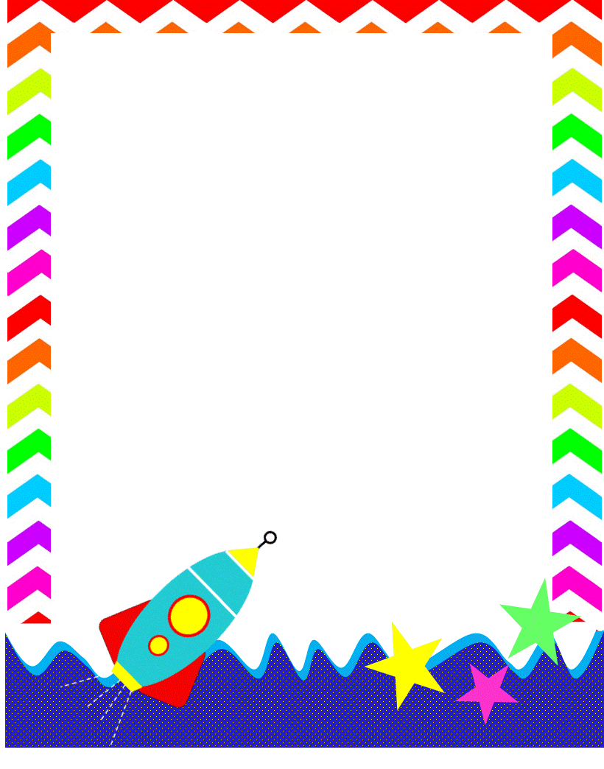**RES Teacher And Staff Favorites List**

**2025-2026**

**Name:Lisa Trierweiler Initals:LTT**

**Birthday: *month & day only* : March 11**

**Preferred t-shirt size?  2x**

**What is your favorite color?  Blue**

**What is your favorite flower/plant?  Tulips, Gerber daisies, any plant (love them)**

**Where are your favorite places to shop?  Target, TJ Maxx, Marshalls, Kirklands, Home Goods, Walmart**

**What are your favorite restaurants?  Carrabbas, Chick fila, Outback, Tazikis, Jimmy Johns**

**What do you collect (candles, foxes, etc.)?  plants, candles, snowmen,**

**What is your favorite cold drink?  Coke zero, sugar free vanilla iced coffee, water**

**What is your favorite hot drink?  Coffee, (any-latte, cappuccino, etc)**

**What is your favorite sweet treat?  Gummy bears, Reese’s peanut butter cups**

**What is your favorite salty treat? Chips and Salsa, pretzels**

**What is your favorite fruit?  Cantaloupe, strawberries, blueberries, honeycrisp apples(really any)**

**Do you have any food allergies? None**

**Interests:**

**UMOJA House: Ukarimu (Green)**

**Wish list for your classroom?**[**https://www.amazon.com/hz/wishlist/ls/Y8R6HMNJ3ZA6?ref_=wl_share**](https://www.amazon.com/hz/wishlist/ls/Y8R6HMNJ3ZA6?ref_=wl_share)